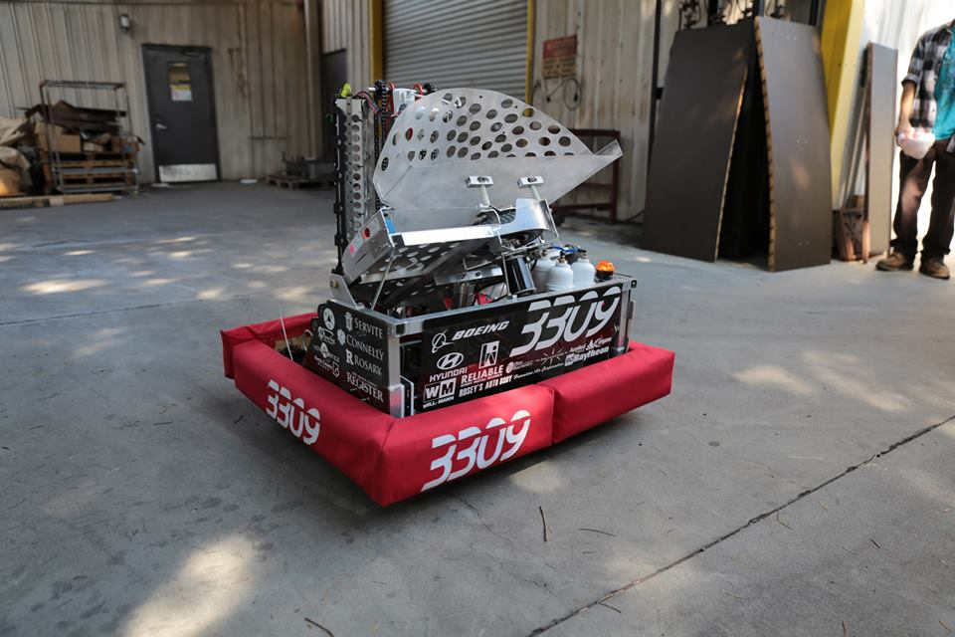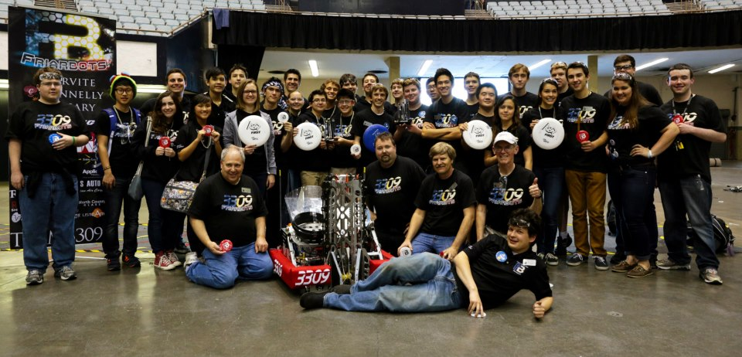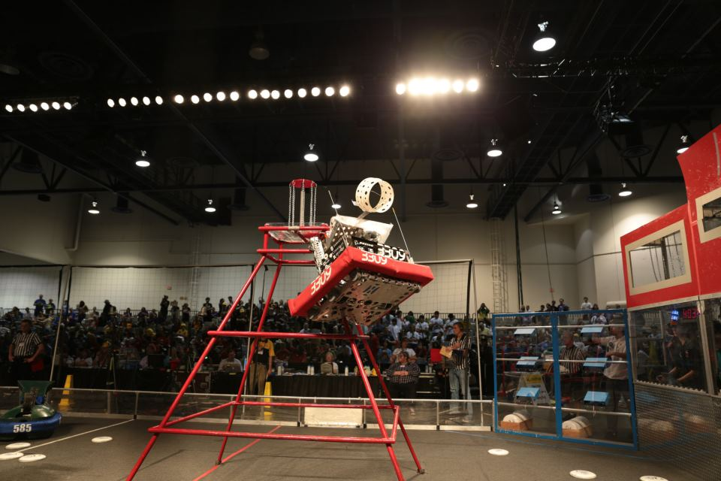 

**Register for the event at team3309.org/discover-robotics2013**

**For Parents/Administrators**

* Presentation by Team Leadership and our engineering mentors
* The importance of Science, Technology, Engineering, and Math in Education
* Starting FLL teams at your middle school
* Coffee

**Sessions for Middle-School Students include:**

* Electrical/Programming
* Computer Aided Design
* Drive Systems and Training to Drive the Robot
* Game Mechanisms- Arms, Shooters, Lifts, and More

This event is completely free.

Lunch will be provided.

**Discover Robotics at Servite High School**

Servite High School Library

1952 W. La Palma Ave

Anaheim, CA 92801

**October 12, 2013 10 AM-2 PM**

Drive our Robot!